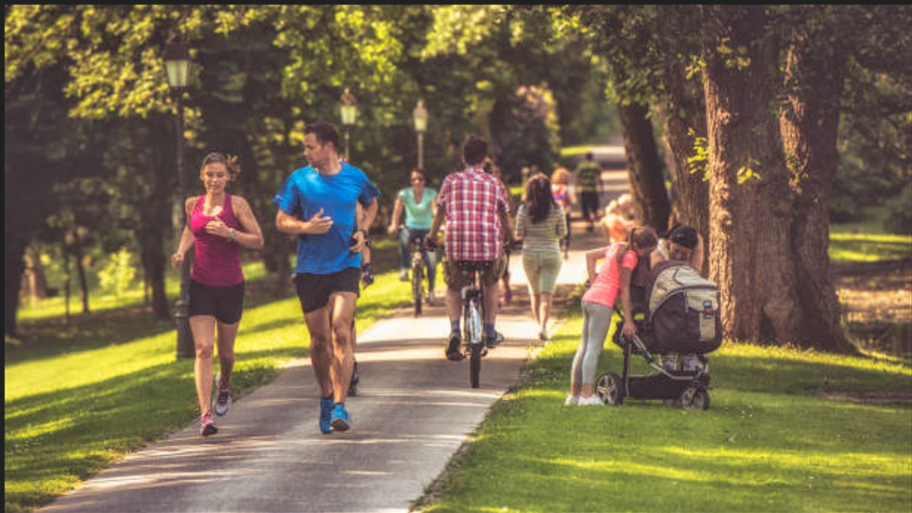

In this picture, I can see a few people in the park. Two people are running; the woman on the left is wearing a red tank top, shorts, and red running shoes. The other person is wearing a blue T-shirt, shorts, and blue running shoes. It looks like they are exercising and they are very happy. Besides, I can see a man wearing a plaid shirt cycling on the path. In the background, there are many trees, and the weather is sunny.

2

In this picture, I can see a group of people engaged in learning or discussing a topic. They seem to be deeply focused on their tasks, perhaps engaged in a discussion or collaborative learning activity. On the table in front of them, there are two laptops, two tablets, and several notebooks, indicating they may be using various digital and traditional resources for their work. In the background, there is a large green board situated at the center of the room, likely used for presentations or writing down key points. To the left, there is a bookshelf filled with books, textbooks, reference materials. On the right side of the room, there is a map attached to the wall.



In this picture, I can see four people watching a movie. I think that there are two separate couples rather than a group of friends, as they are seated in two different row chairs. Although I cannot see the clothes of the two individuals seated behind, the man in front of them is wearing a long gray sleeve shirt, while the other is wearing a V-neck shirt. It seems that they are in a 3D cinema, as they are all wearing 3D glasses and carrying popcorn and soft drinks. They seem to be having a great time, laughing and thoroughly enjoying the movie together.



In this picture, I can see a big family consisting of six people: parents, two children, and grandparents. It seems like the nuclear family has come back to their hometown to visit their grandparents. The elders appear to be very happy during this meal, with Grandma carrying a tray with a turkey on it. They will all enjoy a feast with an abundance of food and drinks. They are gathered in a lovely house, likely the grandparents' residence. It appears that they are celebrating Thanksgiving holiday.

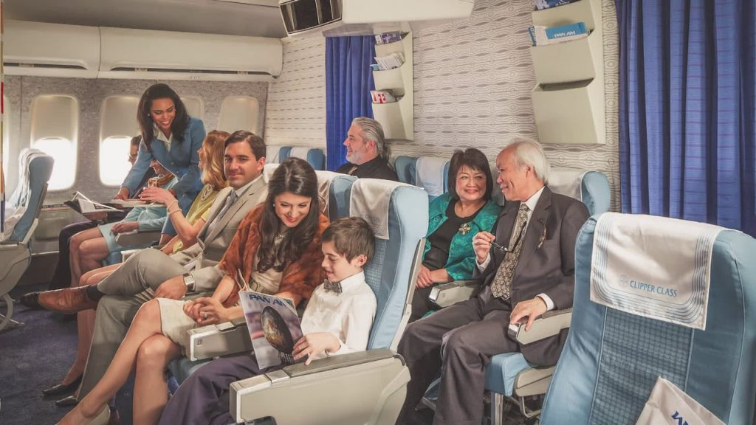

In this photograph, I can see a group of people sitting on blue chairs, and one woman with long blue sleeve shirt is standing and talking to someone. Look like they are in an airplane and the woman who I mentioned is a flight attendant. I believe they all are happy and comfortable with their seats. In the background, there are some magazines placed in special bookshelves which are hanging on the wall. There are also a lot of small windows behind the flight attendant. The atmosphere seem quite cold because I might see that there are some air conditioners on the top left of the picture.

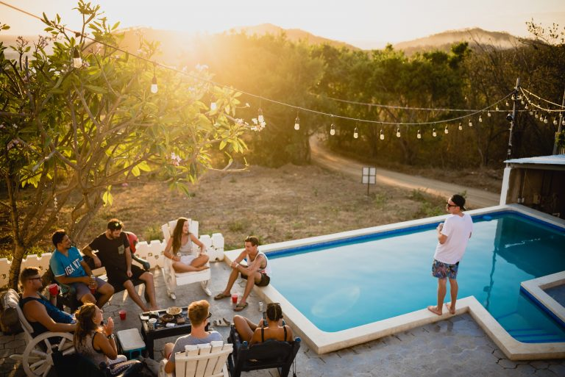

In the picture, I can see a group of 9 friends staying at a homestay. On the left side of the picture, everyone is gathered and chatting with each other, while on the right side, there is a man standing on the pool deck, looking towards the group of people who are chatting. The man on the right side of the picture is wearing a white T-shirt and floral shorts, with black sunglasses and a cap. The group of friends on the left consists of 3 female friends wearing fitted shirts, while the remaining male friends are wearing blue and gray shorts with short-sleeved shirts. They are having a joyful conversation. Next to them is a pathway, surrounded by many green trees, and behind them are mountains.

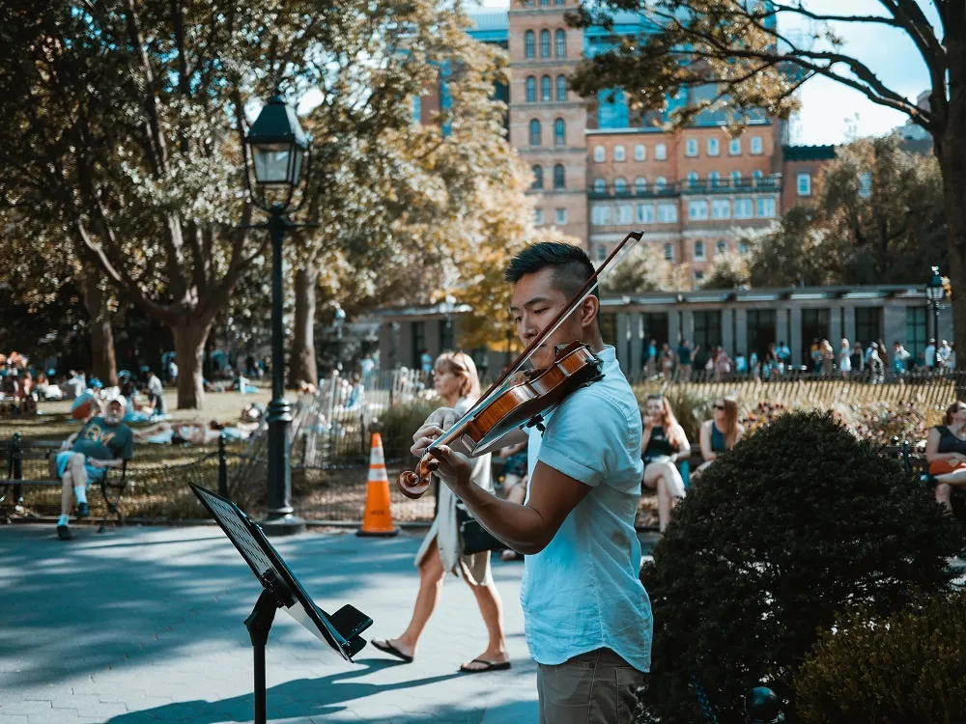

In the picture, I can see a man playing the guitar. Behind him, there are some people sitting on benches in the park. The man playing the guitar is wearing a short-sleeved blue shirt and gray trousers. Behind him, there are two women sitting on a bench, wearing black fitted shirts and black sunglasses. On the left side of the painting, there is an old man wearing green shorts, a T-shirt, and a cap. The man playing the guitar is very focused, while the two women are engaged in conversation.

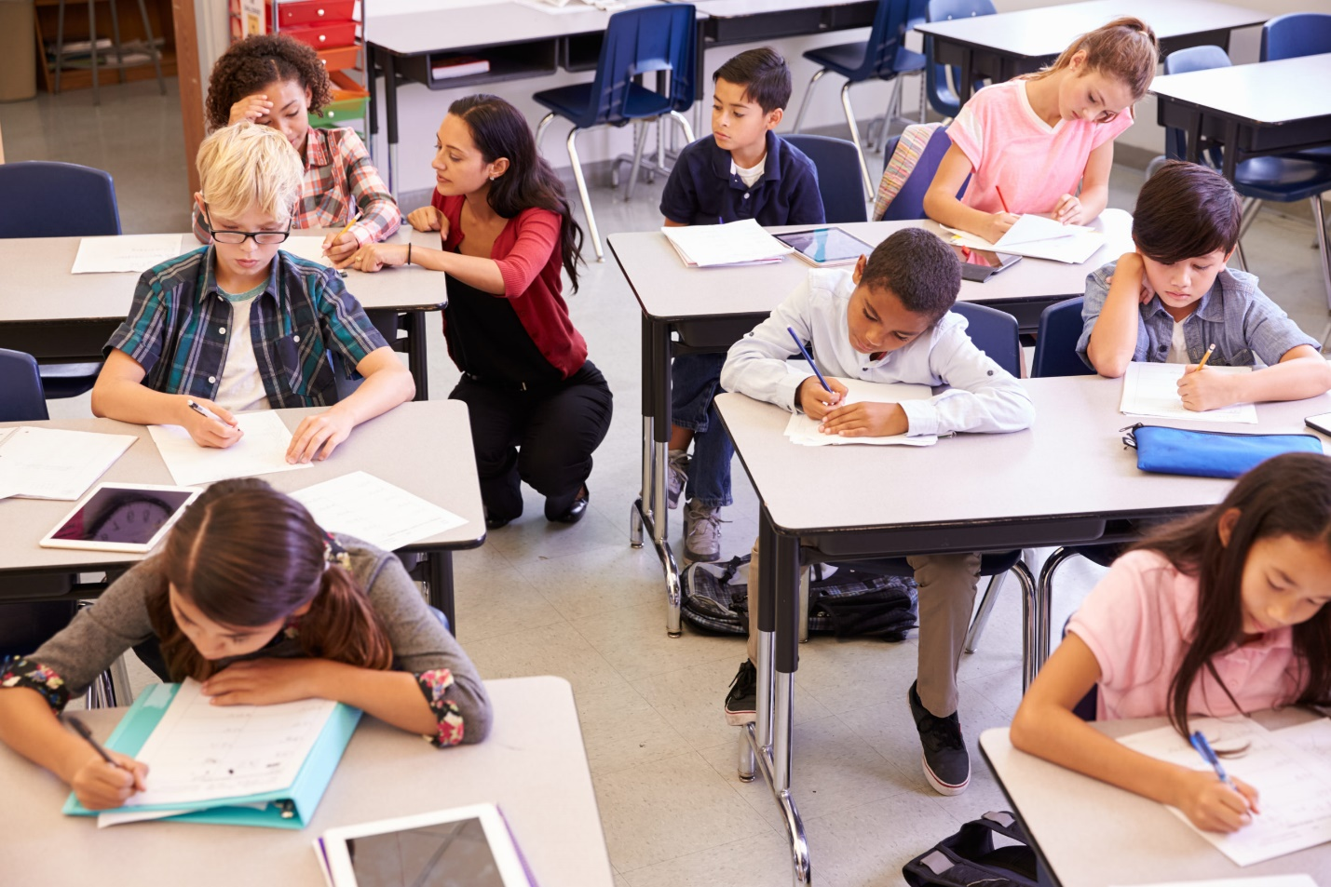

In the picture, I can see a female teacher and her 8 students in a classroom. The teacher is wearing a red outer coat and black fitted trousers. On the right side, the first girl sitting at the desk is wearing a pink T-shirt, and the girl at the end of the class is wearing a white long-sleeved shirt. At the second desk, there is a male student wearing a white long-sleeved shirt, and the student next to him is wearing a blue shirt. The male student at the end of the class is wearing a dark blue shirt. On the left side, the two students behind are wearing shirts with stripes. The girl at the front desk is wearing a gray long-sleeved shirt. They are all very focused on writing, and the girl at the end of the class is attentively listening to the teacher's instructions.

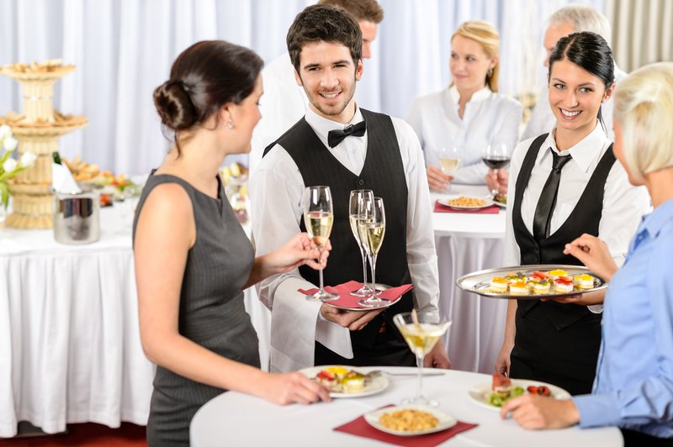

In the painting, I can see 7 people, including 5 guests (3 females and 2 males) and 2 waiters (1 male and 1 female) standing around a table at a party in a restaurant. At the first table, the woman on the left is holding a wine glass and wearing a gray dress. The woman on the right is pointing at the food and wearing a blue shirt. The two waiters standing next to them are wearing white shirts, with one of them also wearing a vest and a bowtie or necktie. At the second table, they are both wearing white shirts, and most of them are holding wine glasses. They are laughing and having a cheerful conversation with each other.



In the picture, I can see on the right side a mother and her two children, and on the left side, there is a dog. They are sitting on a grassy mat next to a pathway. The girl is wearing a blue dress, the girl on the left is wearing denim overalls with a white shirt, and the boy on the right is wearing a blue shirt and shorts. They are attentively reading a book together and appear very happy. The dog beside them has black and golden fur and looks adorable. In the background, there are tall trees in the distance. I think the painting depicts a spring scene because the green trees look vibrant and the lighting is pleasant



In this picture, I can see three people. There are a women and two children. It looks like they are sitting on a sofa. The woman is wearing long black sleeve shirt, jeans. The baby in the mother’s arm is wearing a white clothes. The child next to the baby, who is carrying the tablet, is wearing a white shirt ,jeans and white socks. They are watching tablet together. They seem to be happy.

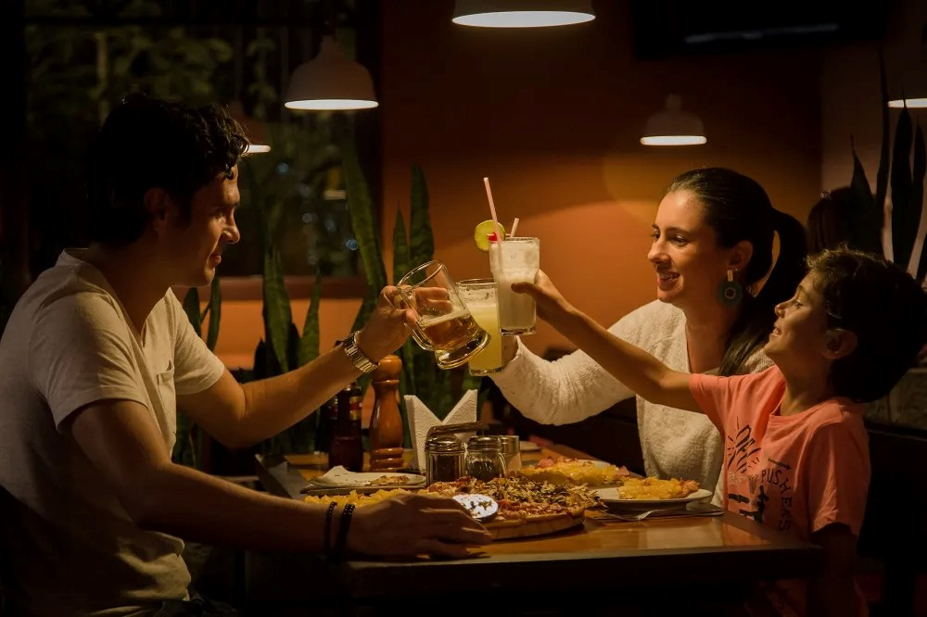

In this photograph, I can see three people. I think they are a family. The father is wearing a white shirt. The mother is wearing long white sleeve shirt and the child is wearing a pink shirt. They are happy dinner together, On the table, there are a lot of food and drink such as pizza, juice. They seem to be really happy because they are having a delicious family meal



In this photograph, (I can see a family consisting of three people) I can see three people. It looks like they are on a living room. I think they are a nuclear family. On the sofa, the father is wearing yellow shirt, black pant and the child is wearing white shirt, orange pant and black sock. The mother sitting on the carpet is wearing gray jacket. I think they are talking together, and the father is carrying a bowl of food so I think he is hungry. On the table, There are a laptop, smartphone and a flower pot. They seem to be really happy.



In the photograph, I can see there are three people, 2 adults and 1 children. They appears to be a small family and they are in a kitchen. The father is wearing a glasses with white shirt, the mother with a curly hair wearing an orange sweater, and the kid is wearing sweater also, but in a white color. The mother and her kid, I believe they are trying to make some food. The kid is helping to add some flavor while the mother is filming that moment. The father, however, I don’t think he is cooking but he is doing something with the tablet. It is such a warming family.

Hi Thomas,

It’s great to hear from you! I understand that you’re busy, so don’t worry about it. The invitation sounds amazing!

Yes, I’m a big fan of music, so it would be incredible to go to the international music festival with you and your group. Fortunately, I’m free this weekend, so we can go.

I suggest we buy some snacks and drinks there. This will be my first time at a big music festival, I’m going to buy some souvenirs.

Could you come to the MD train station? I’ll be waiting there.

See you soon,  
Duc



There are 5 people getting into the boat in the picture. In the background, I can see 3 cruise ships: 2 white and 1 black. The woman at the top of the line is wearing a pullover with blue trousers, carrying a white bag on her shoulder, and holding another black bag. The man behind her is wearing a long-sleeve shirt with black trousers, carrying a yellow basket, and holding a cup. They seem very happy, and it looks like they are enjoying their trip. The weather is sunny, making it perfect for their vacation.

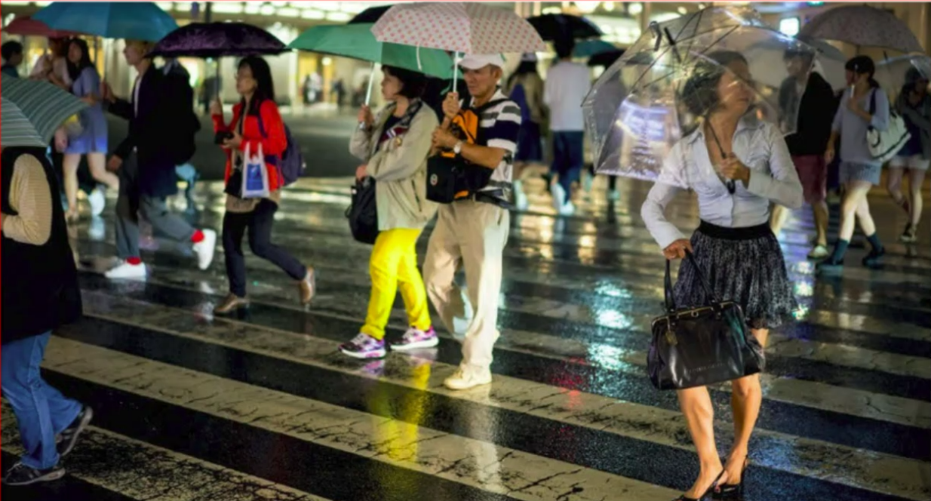  
There are a lot of people in the picture, and I guess they are pedestrians crossing a crosswalk. In the middle of the picture, I can see a man holding a polka-dot umbrella. He is wearing a plaid shirt, white trousers, and a bag in front. Next to him is a girl holding a green umbrella. She is wearing a coat with yellow trousers and carrying a bag on her shoulder. It seems like the weather is rainy because the road is very wet, and everyone is holding umbrellas.

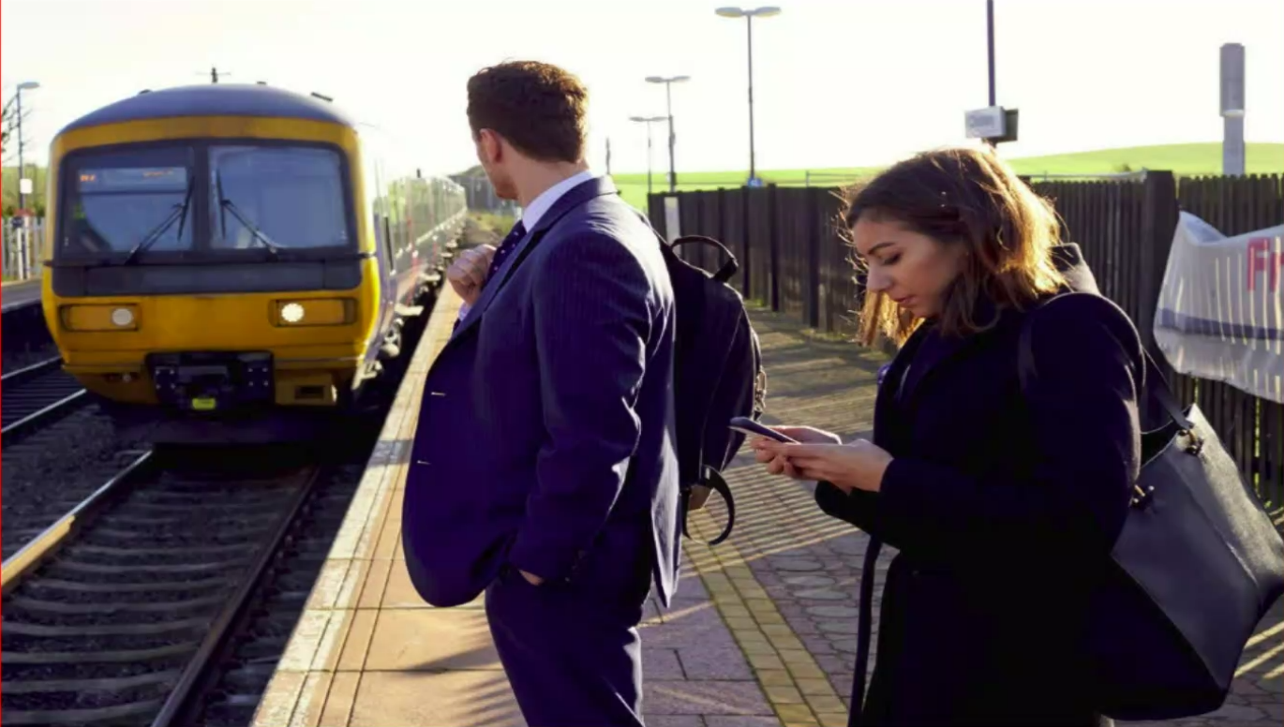

There are 2 people in the picture, 1 man and 1 woman.

